|  |  |
| --- | --- |
| **Name** | Muhammad Arslan Raza |
| **Section** | A |
| **Roll no.** | 2020-EE-403 |

**Lab 8**

**Experiment no. 7**

**Find the effectiveness of Cooling Tower Trainer**

**Introduction:**

**Cooling towers are a special type of** heat exchanger that allows water and air to come in contact with each other to lower the temperature of the hot water. It is an important part of power plants. A water store unit called pond is placed at the base of the cooling tower. The basic **working principle of cooling tower** is to cool the hot water with the help of atmospheric air. During this process, small volumes of water evaporate, lowering the temperature of the water that’s being circulated throughout the cooling tower. In a short summary, a cooling tower cools down water that gets over heated by industrial equipment and processes to re-use this water again. This hot water is coming from the condenser. In [steam power plant](http://www.mechanicaltutorial.com/introduction-and-types-of-thermal-power-plant), cooling tower first collects hot water from the condenser at a certain height from the ground level, after that the hot water falls down by the radial spray. The atmospheric air which is comparatively cool enters at the bottom of the tower. Now the hot air in the cooling tower expose in the atmospheric air which reduces the temperature of the hot water by partial evaporation. This cooled water is collected in the pond at the base of the tower and pumped into the condenser for further use.

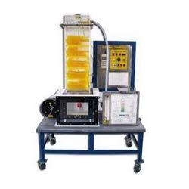

Figure 1: Model of Cooling Tower trainer

**Types of cooling tower:**

**Cooling tower** can be classified into following categories.

* **Natural draught cooling tower**
* **Forced draught cooling tower**
* **Induced draught cooling tower**

**1. Natural draught Cooling Tower:**

The circulation of air is produced in natural draught cooling tower by the pressure difference of air inside and outside the cooling tower.It is an open direct contact type heat exchanger where hot water from system or condenser gets cooled by direct contact with fresh air. Cooling towers use the principle of evaporation of water against the air flow.

**2. Forced draught Cooling Tower:**

In forced draught cooling tower, the circulation of air is produced by fans placed at the base of the tower. In this system, fan is located near the bottom and on the side. This fan forces the air from bottom to top. An eliminator is used to prevent loss of water droplets along with the forced air.

**3. Induced draught Cooling Tower:**

In this type of Cooling Tower, a fan mounted on the top pulls the air through fills. The air is drawn into the cooling tower via air intake mesh. Induced draft cooling tower comes in square or round shape. The distribution of water may be done either by static branch system or by the sprinkler. It is easy to install and maintain. Cooling tower motor drives the induced draft fan to draw the outside air into the cooling tower, which takes out the vapors resulting in lowering the water temperature.

**Parts list and details:**

Following are the parts of Cooling Tower:

**Fills/Columns:**

Cooling Tower Fill is the main heat transfer area available for Heat transfer from Hot water to Cold Air. It reduces the falling speed of hot water and it is similar to beehive.

**Cold Water Basin:**

It has got two functions. One is to collect the cold water from tower and acts as storage. The other is being strong it acts as a foundation for the main structure of cooling tower.

**Fan Deck & Fan cylinder:**

Fan deck provides a platform for the support of the fan cylinders and acts as access way to the fan and water distribution system. Fan cylinder is venture shaped for enhancing the proper flow of air through the tower.

**Condenser Accumulator tank:**

A cooling tower receives warm water from a chiller. This warm water is known as condenser water because it gets heat in the condenser of the chiller.

**Air inlet louvers/Air distributor chamber:**

The primary function of the air intake louvers in a cooling tower is to act as a barrier for sunlight, noise, water splash-out and debris while also improving the airflow of the cooling tower and improving its appearance.

**Cooling Tower Basin heaters:**

Cooling Tower Basin heaters prevent the cold-water basin from freezing up during the winter weather conditions.

**Cooling Tower Sprinkler Head:**

Cooling tower sprinkler head is a device mounted on top of the stand pipe together with the sprinkler pipes on the cooling tower. Through circulating water in the tower, the sprinkler, mainly through its head, is rotated by its pressure.

### Cooling Tower Piping:

Cooling tower piping chief function is to distribute water in the cooling tower. The magnitude and routing of the water piping between the heat source and the location of the tower depending on the kind of tower, site layout, and the topography.

**Spray Nozzles and Header/Water distributor:**

These parts are used to increase the rate of evaporation by increasing surface area of water.

**Bleed Valve:**

It is used to control the concertation of minerals and salt.

**Mesh:**

When the fan is ON, it uses atmosphere air which contains some unwanted dust particles. Mesh is used to stop these particles and do not allow to enter dust in to cooling tower.

**Float Valve:**

It is used to maintain level of water.

**Make up water tank:**

Make up water tank to a cooling tower is necessary to replace the mechanical carryout of water droplets (windage), evaporation, and the blowdown required to maintain a controlled solids buildup. Makeup water usually is added to the cooling tower basin so in case of over flow it get out of basin and gather in the make up water tank.

**Overflow:**

If the water level in the basin gets too high, it will flow through here and out to a drain.

**Water pump:**

Closed loop cooling systems are essentially designed to remove unwanted heat, and often use water cooling pumps to circulate chilled water around.

**Water filter:**

Side stream filtration systems continuously filter a portion of the cooling water to remove suspended solids, organics, and silt particles, reducing the likelihood of fouling and biological growth, which in turn helps to control other issues in the system such as scaling and corrosion.

**Anemometer:**

The anemometer counts the number of rotations, which is used to calculate wind speed. An anemometer is an instrument that measures wind speed and wind pressure. As the wind blows, the cups rotate, making the rod spin. The stronger the wind blows, the faster the rod spins.

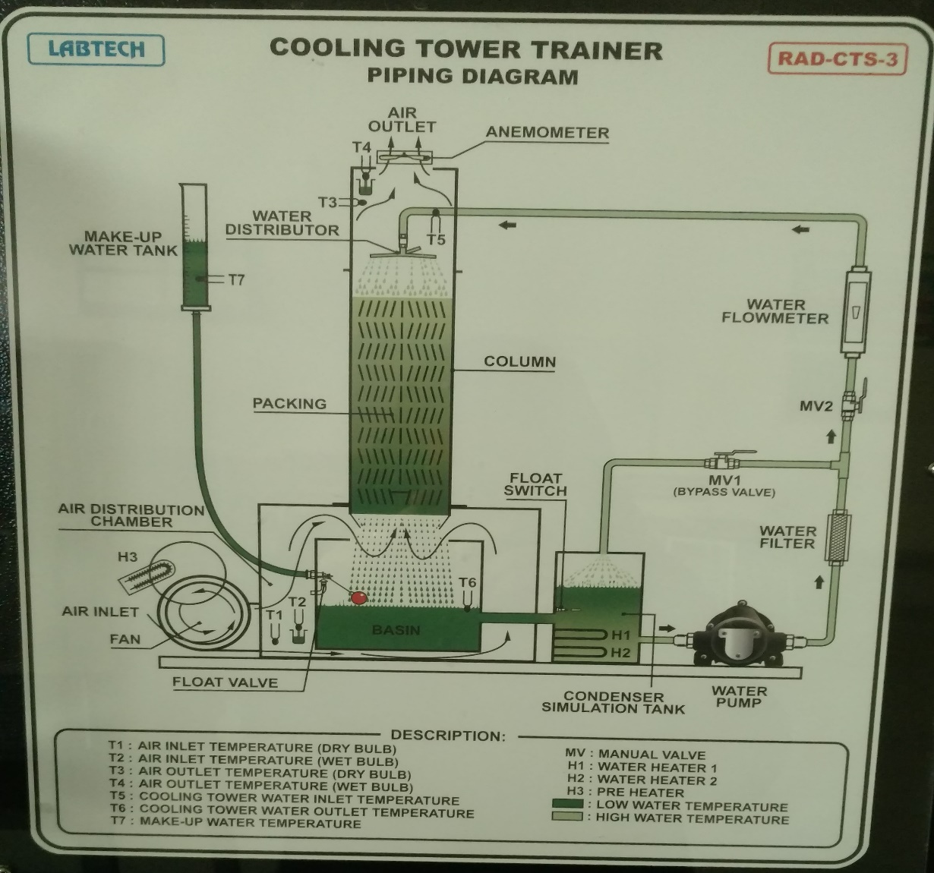

Figure :Parts of Cooling Tower

**Explanation:**

Cooling towers are used to reject heat through the natural process of evaporation. Warm recirculating water is sent to the cooling tower where a portion of the water is evaporated into the air passing through the tower. As the water evaporates, the air absorbs heat, which lowers the temperature of the remaining water. This process provides significant cooling to the remaining water stream that collects in the tower basin where it can be pumped back into the system to extract more process or building heat, thereby allowing much of the water to be used repeatedly to meet the cooling demand.

The hot water is usually caused by air conditioning condensers or other industrial processes. That water is pumped through pipes directly into the cooling tower. Cooling tower nozzles are used to spray the water onto to the “fill media”, which slows the water flow down and exposes the maximum amount of water surface area possible for the best air-water contact. The water is exposed to air as it flows throughout the cooling tower. The air is being pulled by an motor-driven electric “cooling tower fan”.

|  |  |
| --- | --- |
|  |  |

When the air and water come together, a small volume of water evaporates, creating an action of cooling. The colder water gets pumped back to the process/equipment that absorbs heat or the condenser. It repeats the loop over and over again to constantly cool down the heated equipment or condensers. Evaporative cooling is the process where warm water from an industrial process is pumped up to the top of the cooling tower where the water distribution system is. The water then gets distributed by cooling tower nozzles to the wet deck. At the same time, air is being drawn through the air-inlet louvers forcing water to evaporate. Evaporation causes the heat to be removed from the make up water. The hot air naturally rises out of the tire.

Figure 3:Working of Cooling tower

**Readings:**

T1= Air inlet temperature (Dry bulb)

T2= Air inlet temperature (Wet bulb)

T3= Air outlet temperature (Dry bulb)

T4= Air outlet temperature (Wet bulb)

T5= Cooling Tower water inlet temperature

T6= Cooling Tower water outlet temperature

T7= Make up water temperature

Range= T5-T6

Approach= T6-T2

Effectiveness= range/range+approach

|  |  |  |  |  |  |  |  |  |  |  |  |
| --- | --- | --- | --- | --- | --- | --- | --- | --- | --- | --- | --- |
| Velocity  (m/s) | Flow rate  (m3/s) | Temperature (oC) | | | | | | | Range  (oC) | Approach  (oC) | Effectiveness |
| T1 | T2 | T3 | T4 | T5 | T6 | T7 |
| 6.5 | 7 | 12 | 12 | 15 | 17 | 18 | 15 | 11 | 4 | 2 | 66% |
| 7.8 | 8 | 14 | 13 | 16 | 16 | 17 | 16 | 17 | 1 | 3 | 25% |

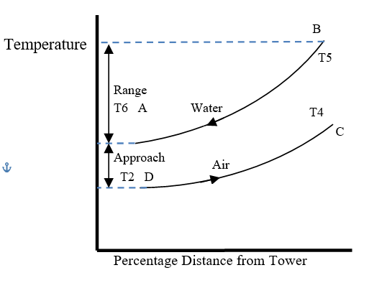

Figure no. 8.4: Temperature Relationship Between Water and Air in Cooling Tower

**Difference b/w Wet bulb and Dry bulb:**

The wet-bulb temperature (WBT) is the temperature read by a thermometer covered in water-soaked cloth (wet-bulb thermometer) over which air is passed. At 100% relative humidity, the wet-bulb temperature is equal to the air temperature (dry-bulb temperature) and it is lower at lower humidity. It is defined as the temperature of a parcel of air cooled to saturation (100% relative humidity) by the evaporation of water into it, with the latent heat supplied by the parcel. A wet-bulb thermometer indicates a temperature close to the true (thermodynamic) wet-bulb temperature. The wet-bulb temperature is the lowest temperature that can be reached under current ambient conditions by the evaporation of water only.

The dry-bulb temperature (DBT) is the temperature of air measured by a thermometer freely exposed to the air, but shielded from radiation and moisture. DBT is the temperature that is usually thought of as air temperature, and it is the true thermodynamic temperature. It indicates the amount of heat in the air and is directly proportional to the mean kinetic energy of the air molecules. Temperature is usually measured in degrees Celsius (°C), kelvins (K), or degrees Fahrenheit (°F).

**Application:**

Common applications include cooling the circulating water used in:

* Oil refineries
* Petrochemical plants
* Thermal power stations
* Nuclear power station
* HVAC systems
* Ventilation purposes